**Wireshark UDP**

* + 1. **Select one UDP packet from your trace. From this packet, determine how many fields there are in the UDP header. (You shouldn’t look in the textbook! Answer these questions directly from what you observe in the packet trace.) Name these fields.**

The header contains 4 fields; source port, destination port, lengh, checksum.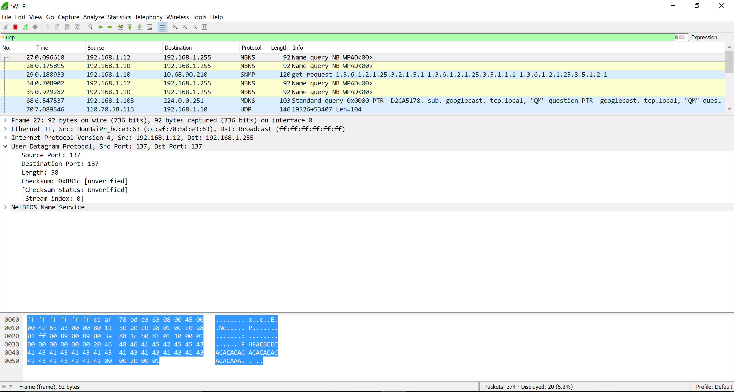

* + 1. **By consulting the displayed information in Wireshark’s packet content field for this packet, determine the length (in bytes) of each of the UDP header fields.**

2 bytes long.

* + 1. **The value in the Length field is the length of what? (You can consult the text for this answer). Verify your claim with your captured UDP packet.**

The value of the length is the sum of 8 header bytes plus the encapsulated data.

* + 1. **What is the maximum number of bytes that can be included in a UDP payload? (Hint: the answer to this question can be determined by your answer to 2. above)**

The maximum number of bytes that can be included in a UDP payload is 216 – 1 less the header bytes. This gives 65535 – 8 = 65527 bytes.

* + 1. **What is the largest possible source port number? (Hint: see the hint in 4.)**

The largest possible source port number is 216 – 1 = 65535.

* + 1. **What is the protocol number for UDP? Give your answer in both hexadecimal and decimal notation. To answer this question, you’ll need to look into the Protocol field of the IP datagram containing this UDP segment (see Figure 4.13 in the text, and the discussion of IP header fields).**

The IP protocol number for UDP is 0x11 hex, which is 17 in decimal value.

* + 1. **Examine a pair of UDP packets in which your host sends the first UDP packet and the second UDP packet is a reply to this first UDP packet. (Hint: for a second packet to be sent in response to a first packet, the sender of the first packet should be the destination of the second packet). Describe the relationship between the port numbers in the two packets.**

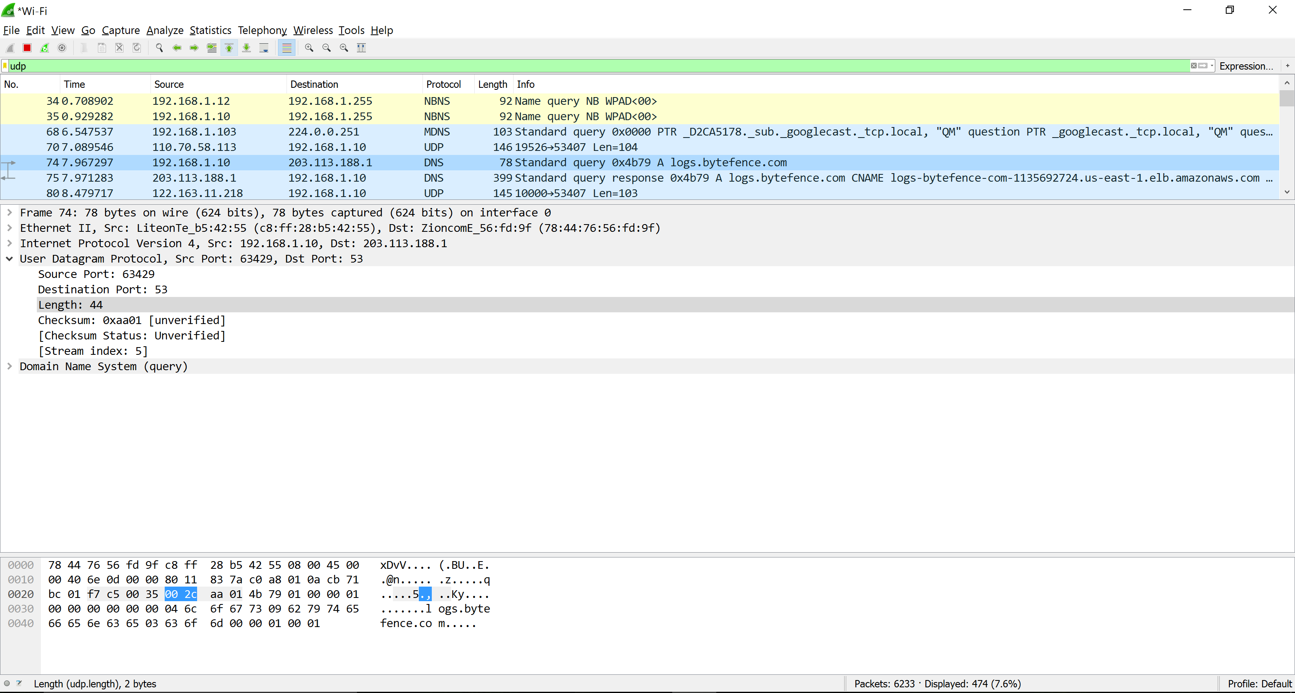

Sent by my host.

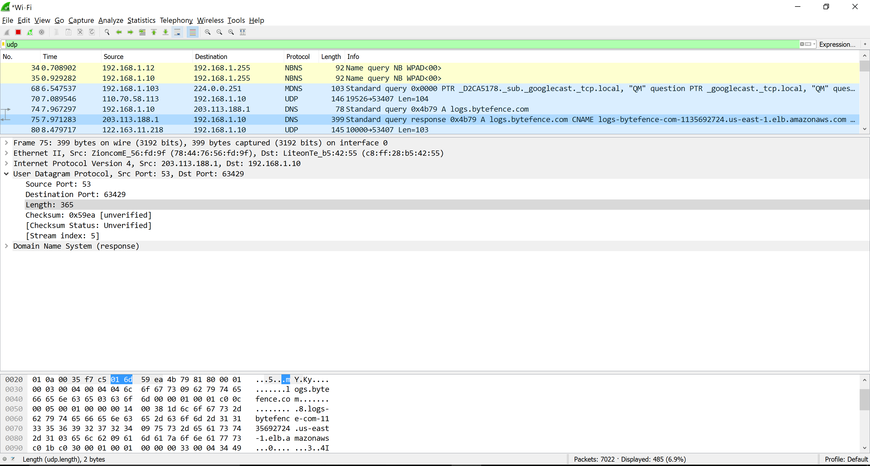

Reply to host.

The source port of the UDP packet sent by the host is the same as the destination port of the reply packet, and conversely the destination port of the UDP packet sent by the host is the same as the source port of the reply packet.